***Smart Application Development***



***Assignment #01***

***Name: Shahzaib Gul***

***Roll no: F-63047 (UET-11)***

***Class: 32(A)***

**Department of Computer Science**

**NUML, Rawalpindi**

**Activity_main.xml**

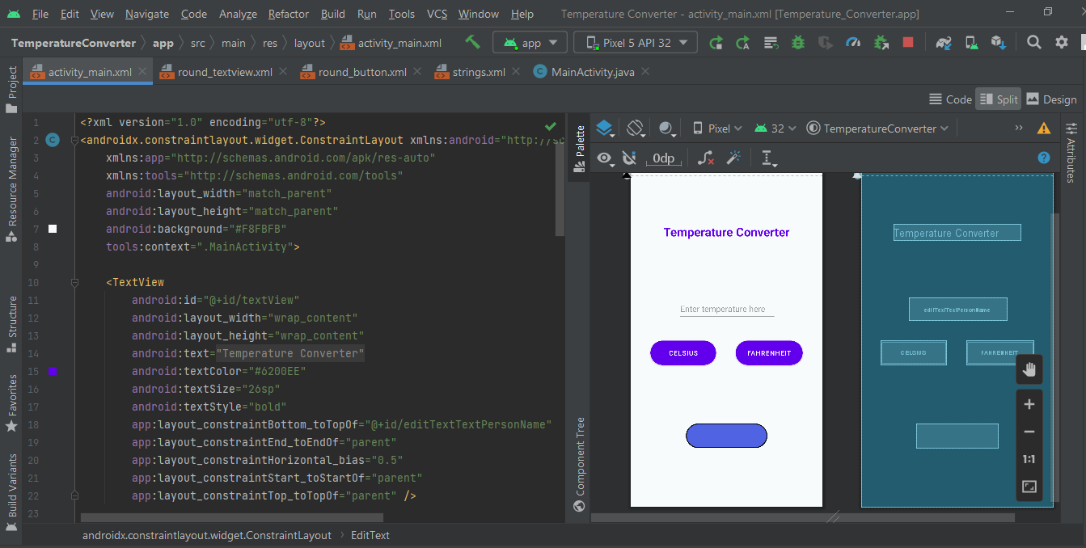

**Round_TextView.xml**

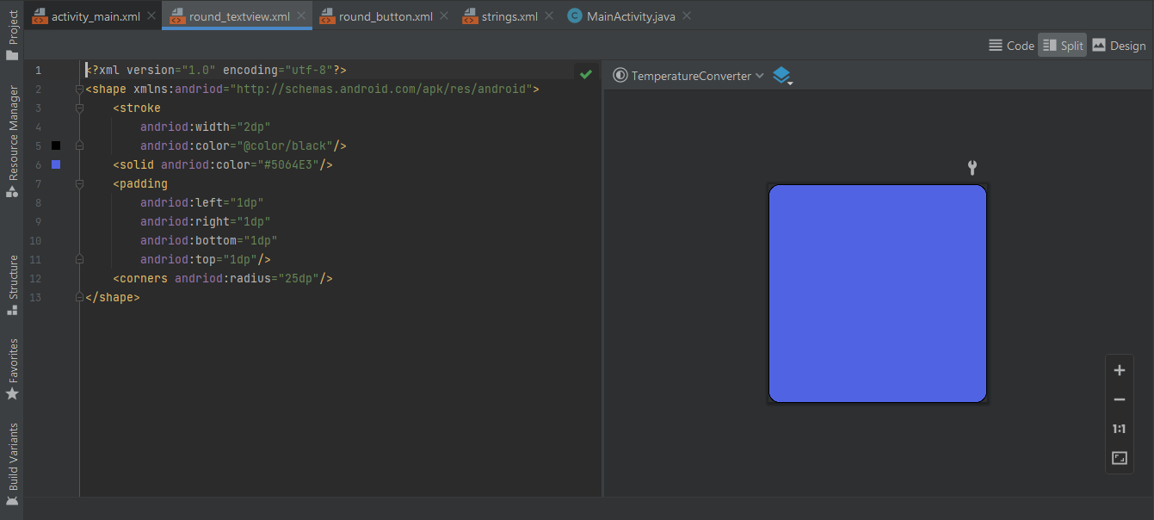

**Round_Button.xml**

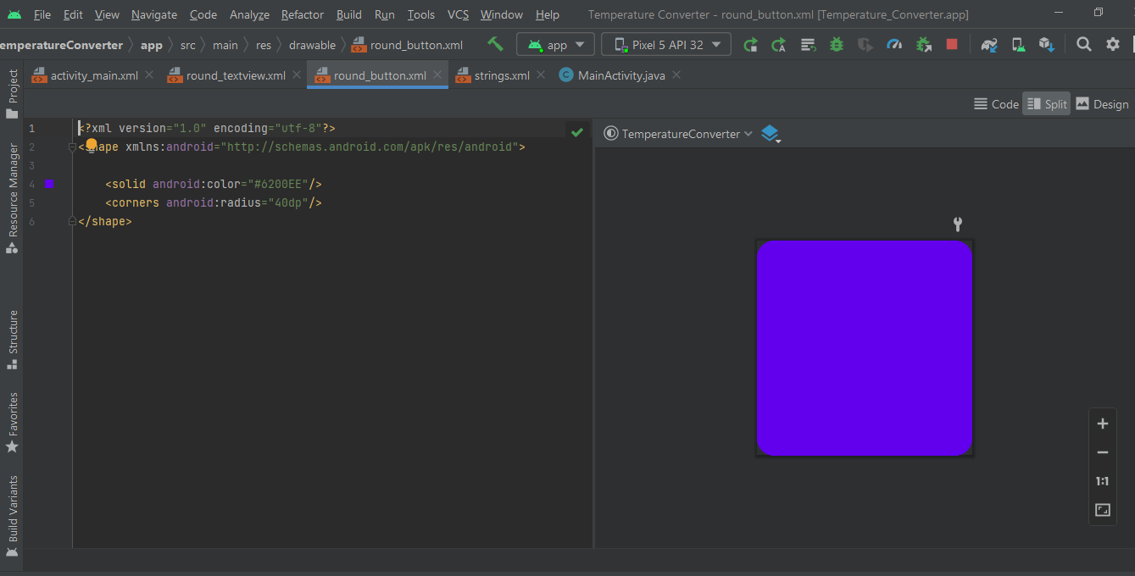

**String.xml**

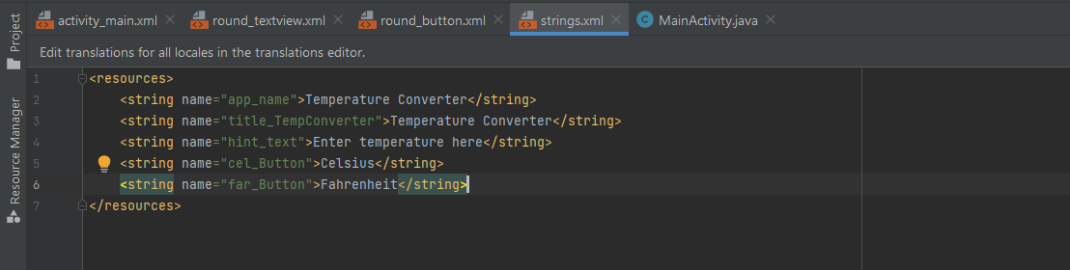

**MainActivity.java**

